Project Report Template

1. INTRODUCTION
   1. Overview

Vehicle Management has four type of users.The administrator of this software beyond this,the administrator can also act as a normal user and book and bus on cab for himself.

* 1. Purpose

The purpose of this application is to keep the record of text in the edition property nd the different text which is issues to the activities. The availability of content can be easily managed and text having different system of library.

1. Problem Definition & Design Thinking

2.1 Empathy map

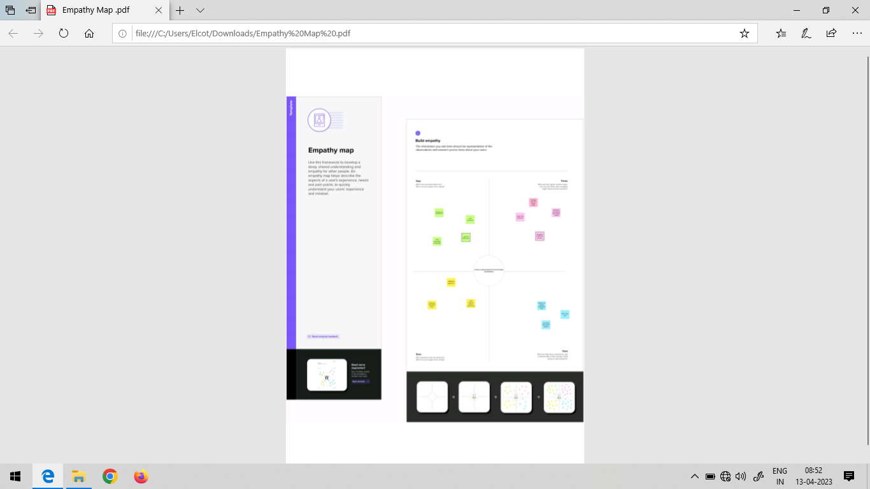

2.2 Ideation & Brainstorm Map

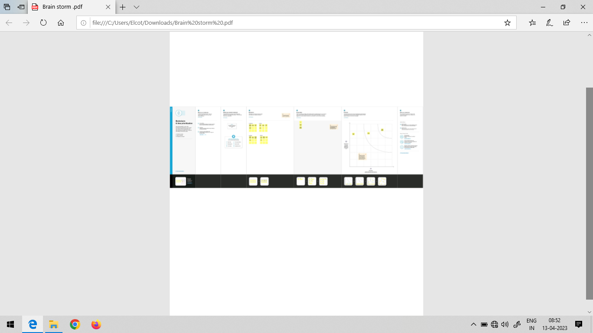

1. RESULT

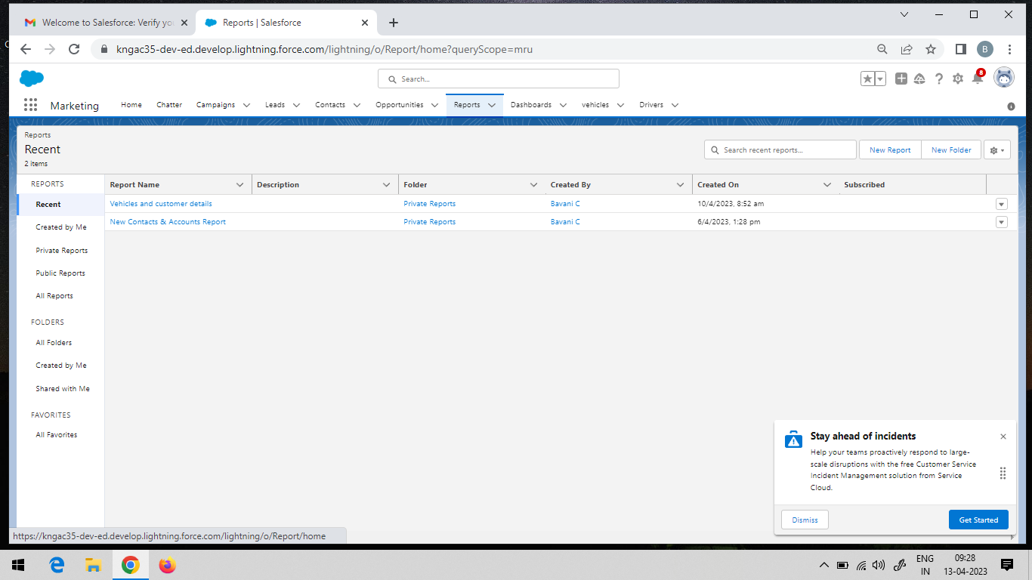

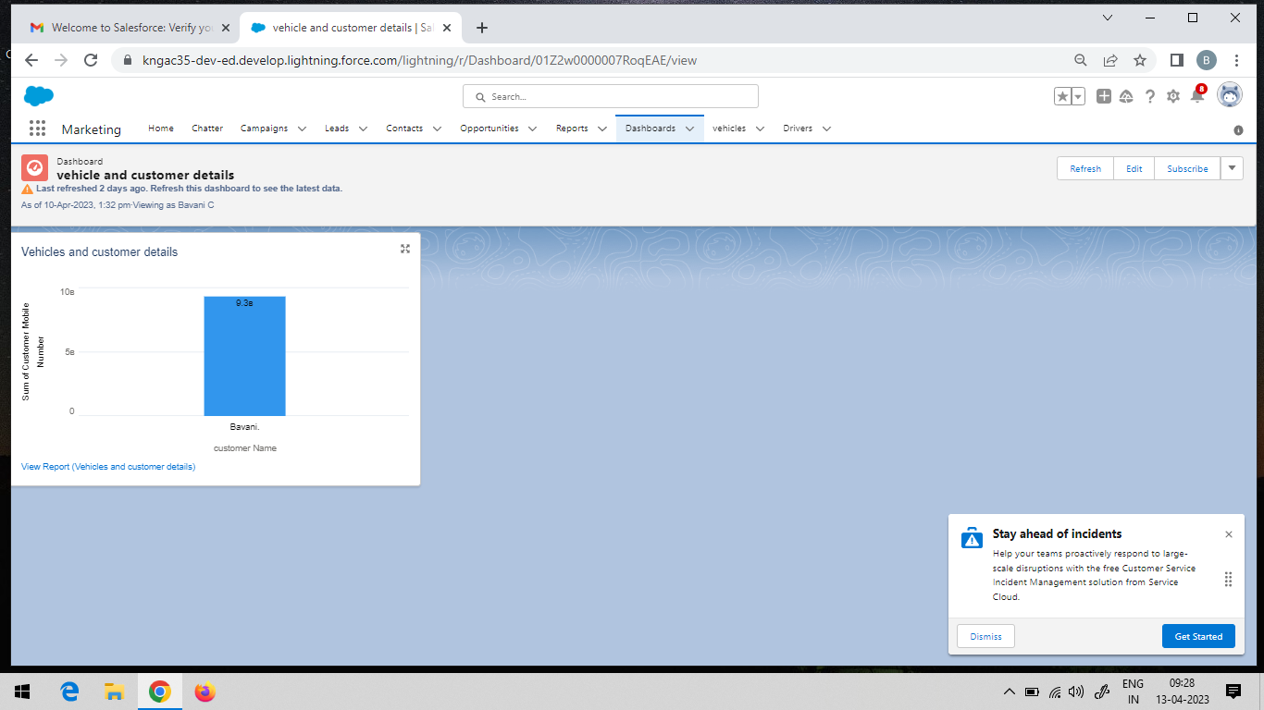

4 ADVANTAGES

* It improves productivity by saving delivery time due to use of advance route information,traffic alerts.
* It helps to reduce cost of fuel
* It ensures safety of vehicles,drivers and goods.
* It provides real time location of fleets and serves the customers in better way.

DISADVANTAGES

* It requires skilled resources to maintain such shstems. This increases maintainance costs.

* GPS device used in fleet management is power hungry which drains battery faster.

*Active trcking based fleet management requires monthly subscription chrger and data usage charger.

**5. APPLICATION**

* The book covers mathematical procedures for the effective and efficient utilization of vehicles developed models for optimization methods.

6.Conclusion

The vehicle mangement system is very greatful system. The safest and most efficient roads.Any education institude can mke use of it for providing information user is vehicle mngement feature.

7.FUTURE SCOPE

The scope of this project is to enhance the facilities available in the current notpad system measures would be application in the future for the student point of view and management point of view. The vehicle management is a greatful opportunity.

8. APPENDIX

